Project On

**Student Unique Identity System (SUID)**

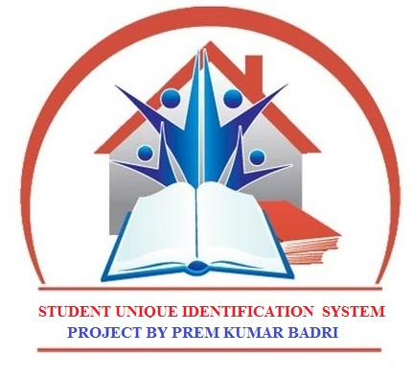

PROJECT BY

**PREMKUMAR BADRI**



**Student Unique Identity System (SUID)**

This system is used to create a tool that manages the handling of Entrance Exam verification, counselling Certificate verification and Interview candidate verification using the student unique identification associated with each individual.

The application deals with allowing the Student to register for a Student unique identity. The Student Unique Identity (SUID) is supported with a pin number.

Student’s being issued Hall tickets or those have who are eligible for counseling they are associated with the SUID. This helps the Student to write exam or attending the counselling without having the Certificates.

The SUID will provide all Certificates to access at Counselling or Interview from the Student Identification server. The details and profile of the Student’s with the photo and copy of the certificates can be viewed as part of Verification at all check times.

The all department can use the application to trace or stop any Fake Students at any verification time. The all department people will get the database access of the SUID they can see and verified the details of the person. If there is any fake person they can make the person disqualified for the place.

The Student uses the SUID scheme to apply for Entrance Exam and counselling. The details of the Students are picked from the registration database. The Student is provided with the test details by the application. The details contain the location, date and time information. The test details are provided to the Student on completion of the test.

**SYSTEM REQUIREMENT SPECIFICATION (SRS)**

# Introduction

## Purpose

To create a Tool that manages the handling of Entrance Exam verification, counselling Certificate verification and Interview candidate verification using the student unique identification associated with each individual.

**Project Scope**

* Student Registration, identification of each Students using SUID(Student Unique Identification Number)
* Secure Entrance Exams application
* Entrance Exam application verification by the authority in online mode.
* Exam Issue & Denial
* Provide Data Base to department’s to integrate with the Company’s, College’s, Exam committees to stop someone who is fake.
* Apply for Interviews and Counselling.
* Provide Test details and scenario – Counselling Committees.
* Provide test result.
* Issue or deny Seats and Jobs.
* Change of address in one ID reflects the change in others.

# System Features

1. **Login & Security**

The module allows only authorized users to use the application. The application comes with a default administrator account. This account has a user id “Admin” and password “Admin” by default. This user can change his password as and when necessary. The administrator maintains SUID seva staffs that are authorized to handle the application and process transactions for the Student.

1. **Student Registration**

The module allows the Student’s to register for Student Unique Identity. The Student provides his personal information, photo, certificates to the registration module. The module acknowledges by providing an application number. The Student uses the application number to then check the status of the Student Unique Identity. The administrator is responsible to set the allocation status.

1. **Process & Issue Unique Identity**

The applications registered by the Student are viewed by the administrator. When the administrator gets the physical verification report only then he confirms the issue of the Student Unique Identity. The module generates Student Unique Identification Number for each application (Student). The SUID is also associated with a password which can be changed by the Student.

1. **Apply Exam, Counselling and Interview’s**

The module allows the Student to register application for Exam, Counselling & Interview. The module auto fills the application with the information already available in the SUID Regn database. Only when there is a change of information the Student should update the SUID Regn database and then apply for Exam, Interview.

1. **Exam, Counselling, & Interview Processing**

The module allows the administrator to verify the details of the application, set the status of the Processes. If the application is accepted then the administrator provides the Application number and the system automatically updates the date of issue and expiry. This information is now available to the Student as well as to the authority. The Documents is a digital Documents. The verification of the Student is done by the Particular Department.

1. **Fake Certificates Control**

The module allows the crime department to view Student information either using the SUID. They can also provide the name of a person and have photos viewed and Documents for the Student having identical names, highly useful when only the name of the person is known. The fake user can also set the status for a exam, counselling and interviews such as Eligible or not Eligible there by intimating the authority of Controlling restrictions for a Student.

1. **Reports**
   * + Exam & Counselling Applications
     + Application & Processing Status
     + Eligible & Not Eligible List.

SYSTEM REQUIREMENT STUDY

**Software Requirement:**

Operating System : Windows XP or Higher

Platform : .NET

Scripting : JSP, CSS

Backend : Microsoft -Sql server

Web Server : IIS

**Hardware Requirement (Minimum)**

Processor : PIV

Ram : 512 Mb

Hard Disk : 10 GB Space

**Software Architecture Diagram**

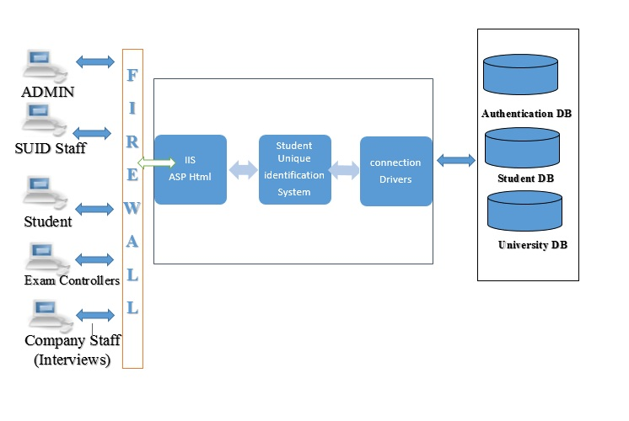

**Deployment Diagram**

Universities & boards server

Universities & boards

Student UID server

Student UID

Companies

Machine

EXAM Controller Machine

Staff Machine

ADMIN

Machine

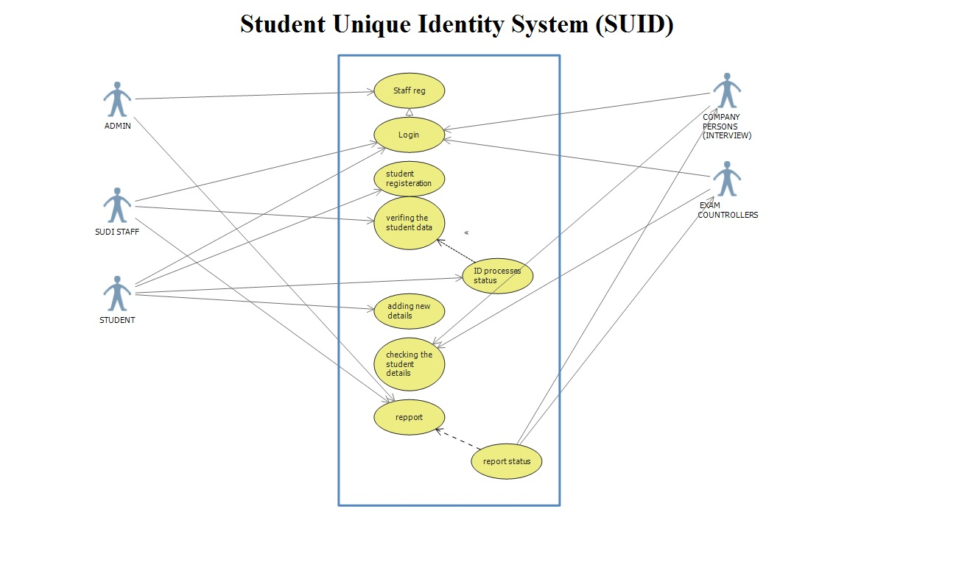**User Case Diagram**

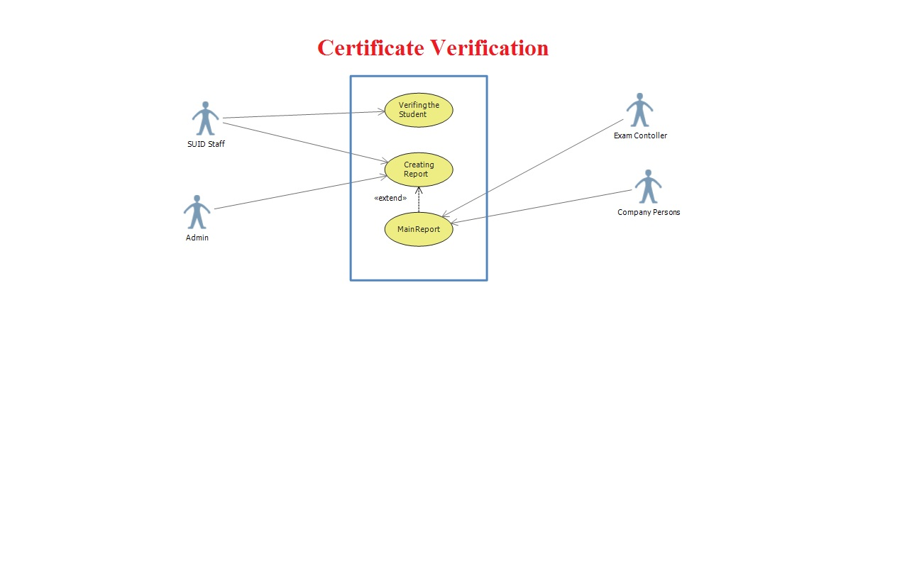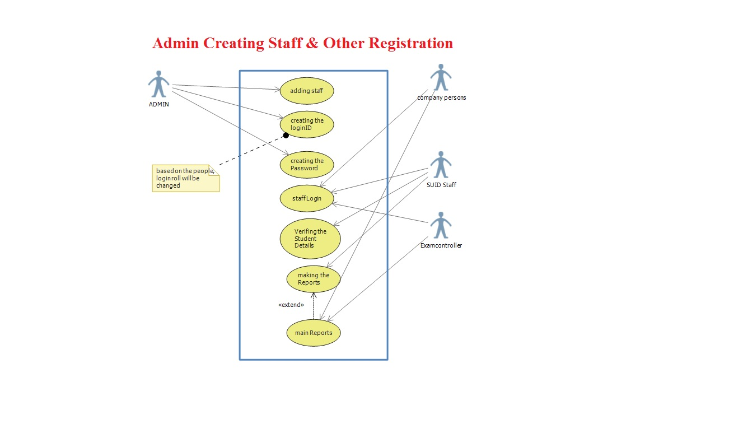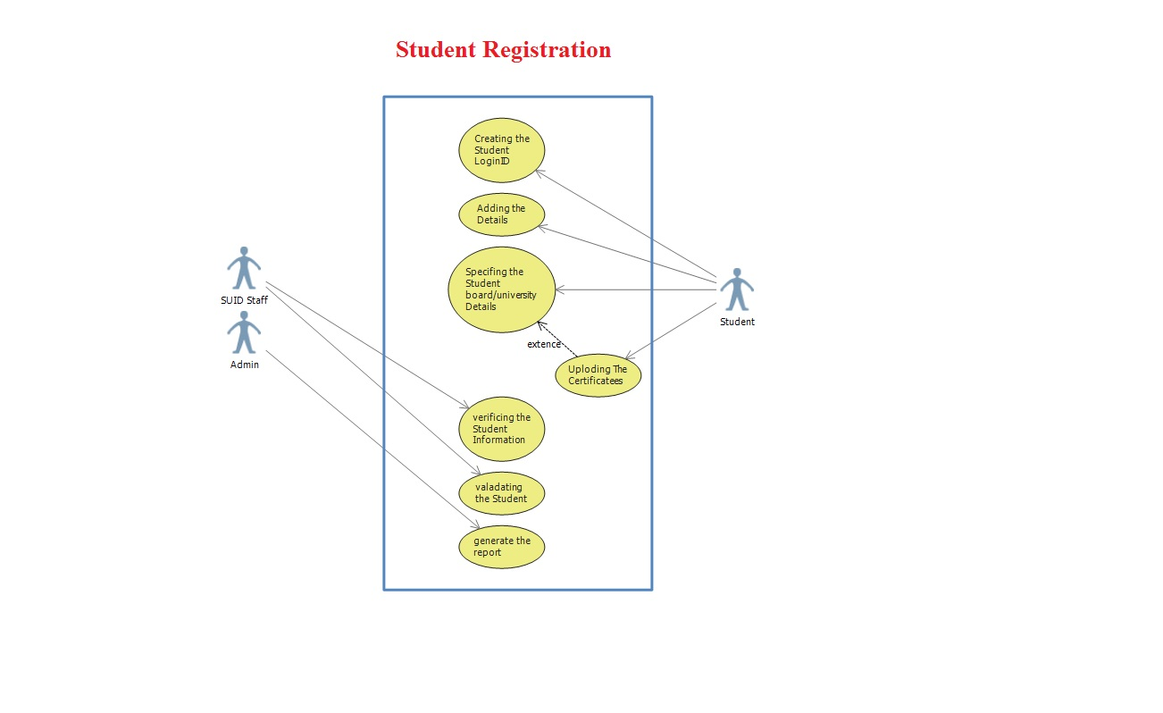

**Sequence Diagram**

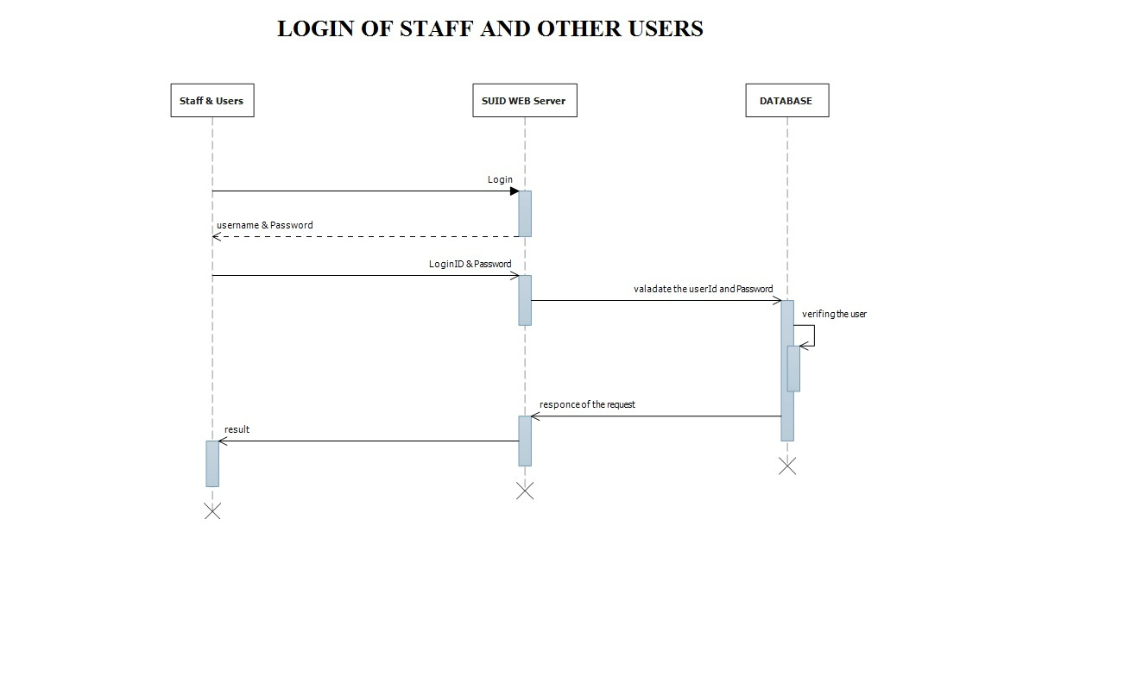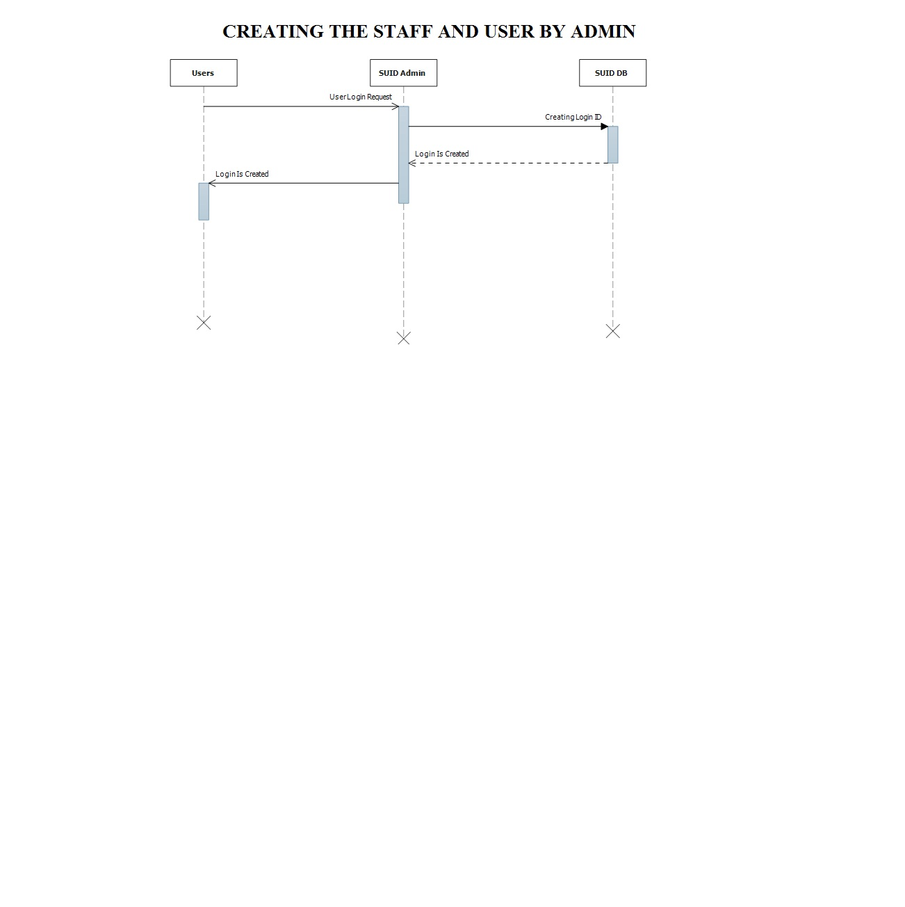

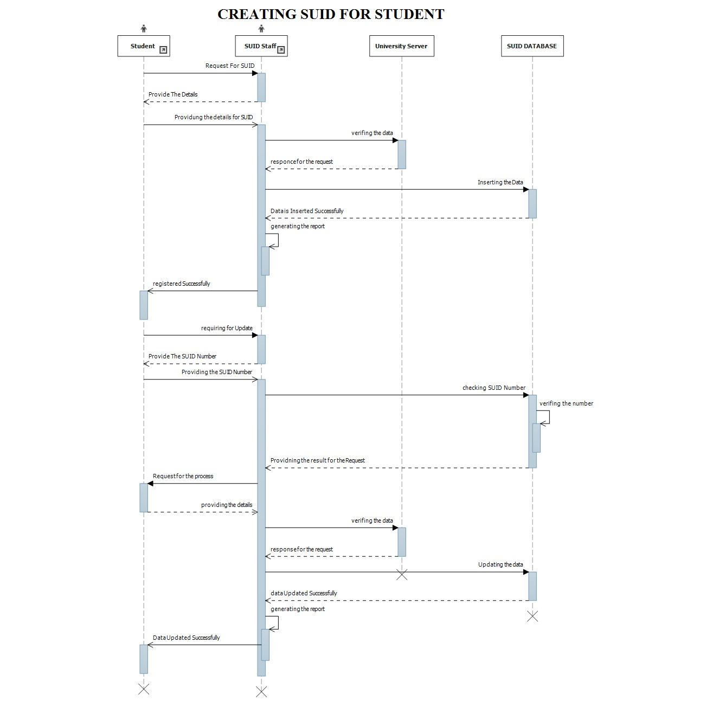

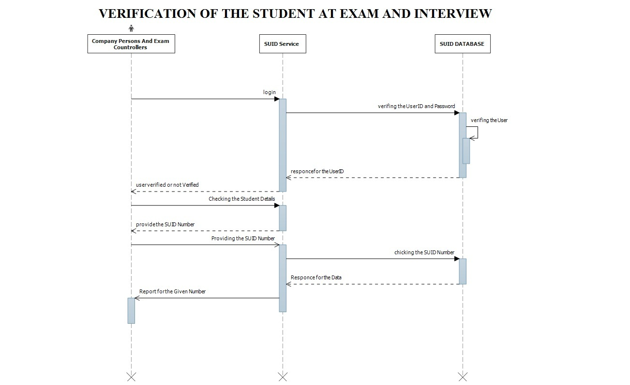

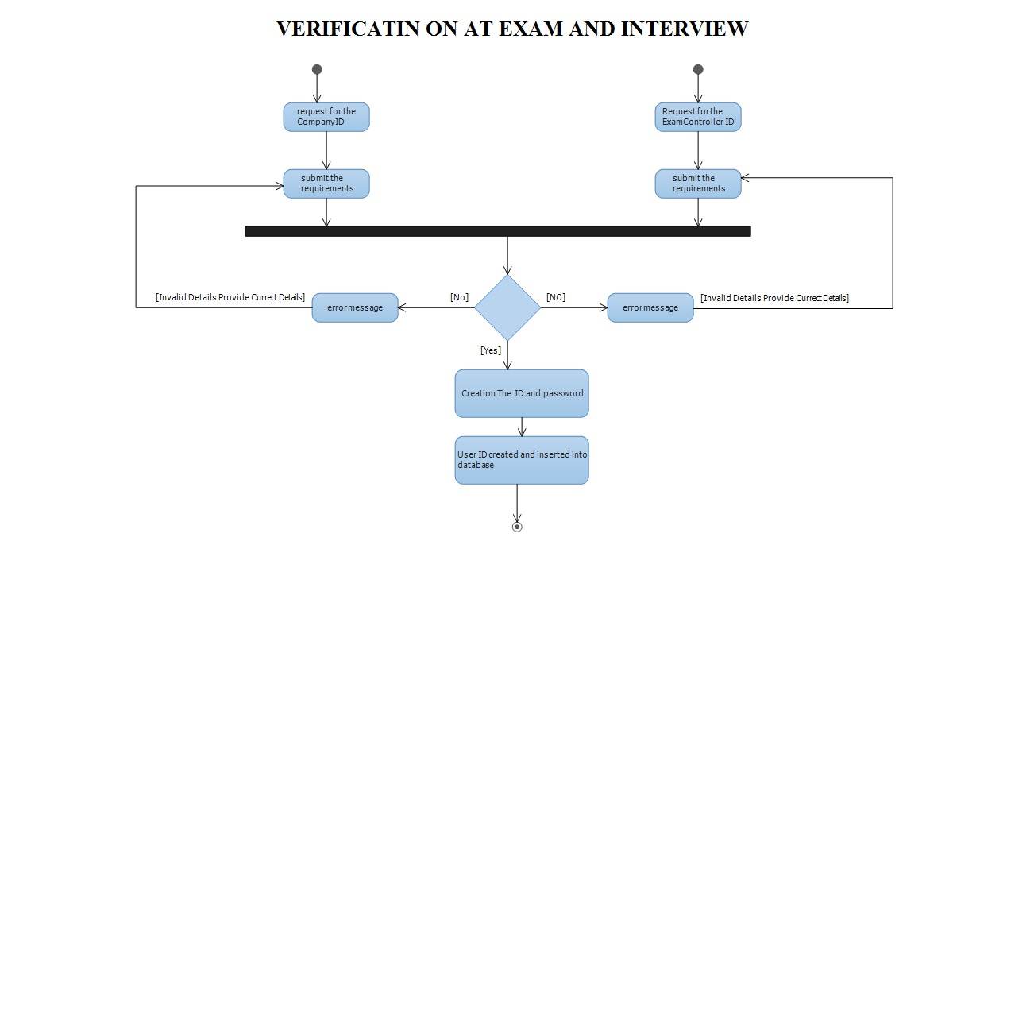**Activity Diagram**

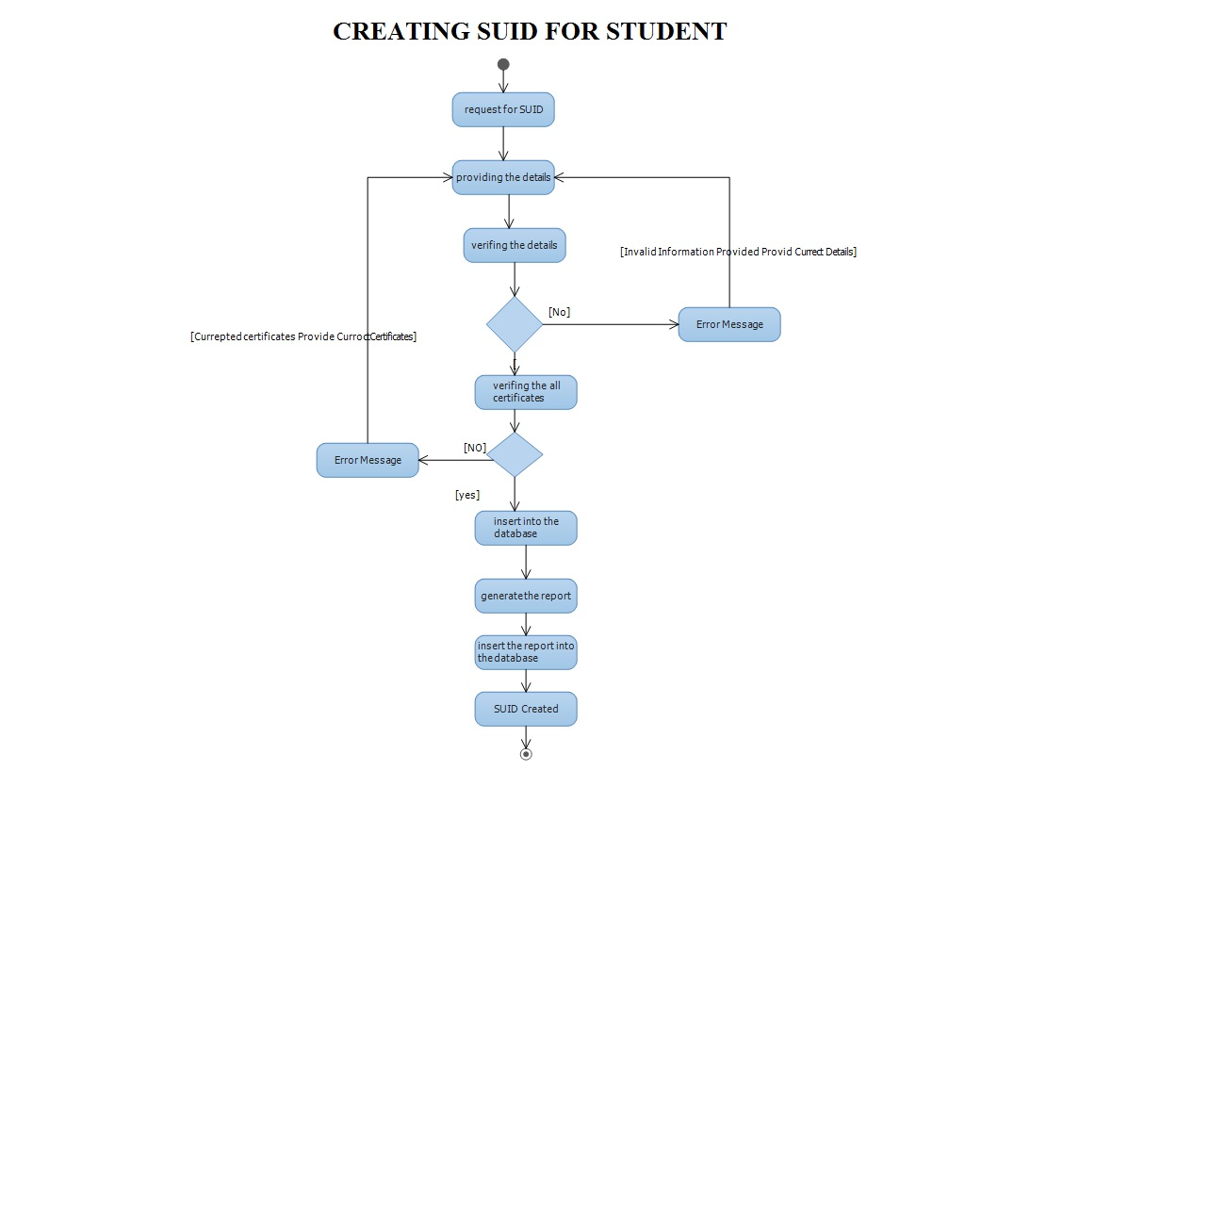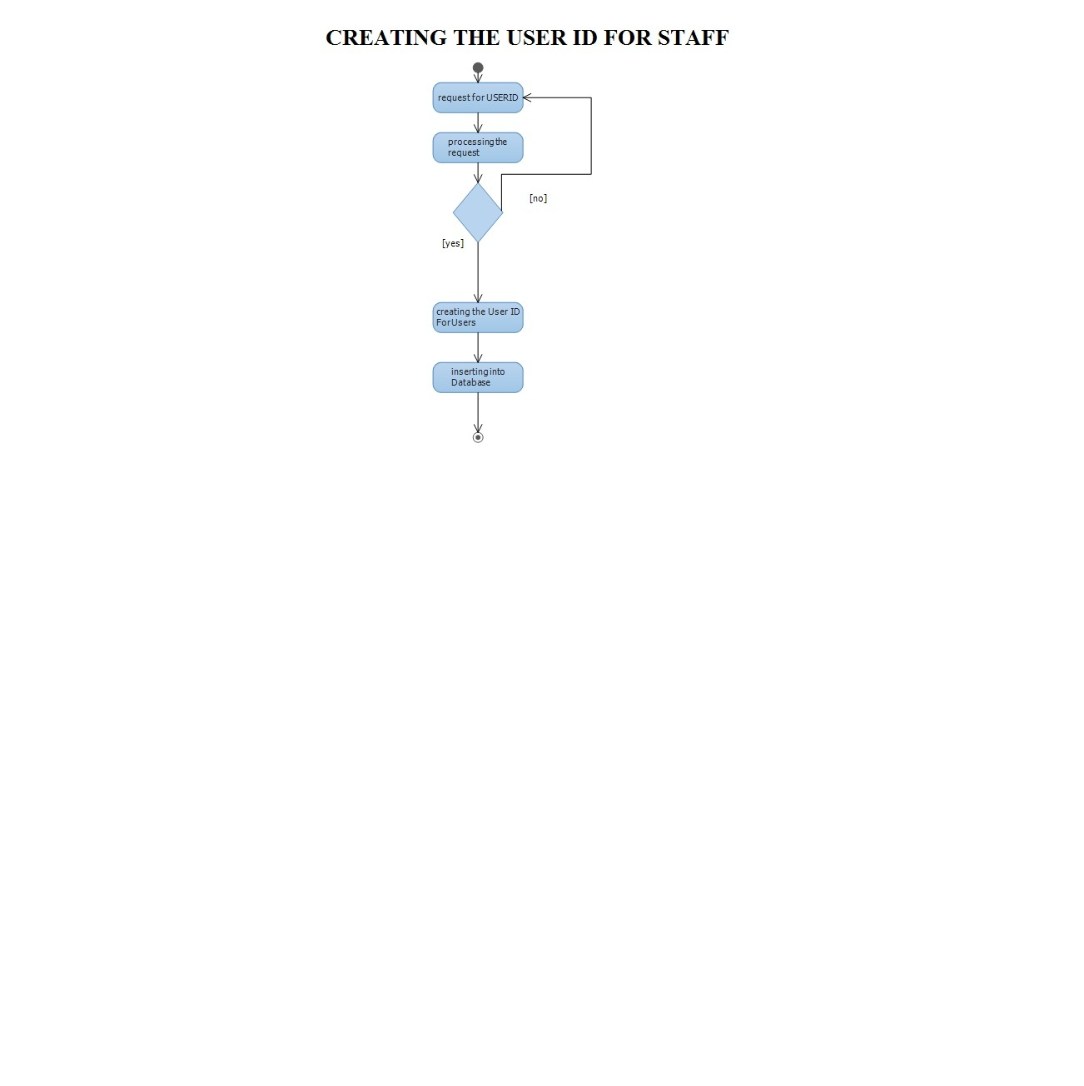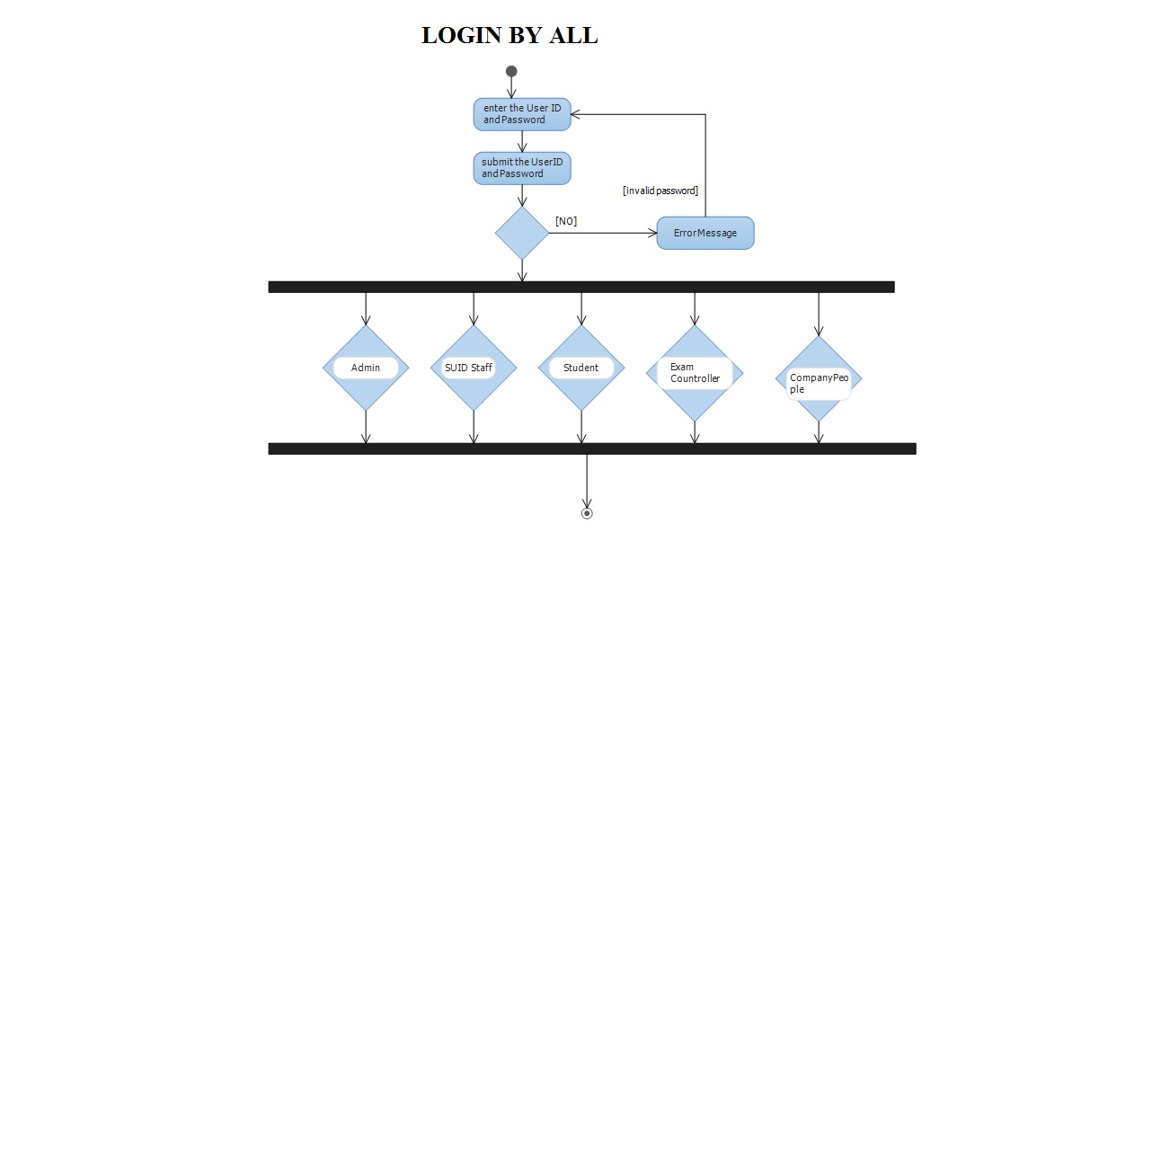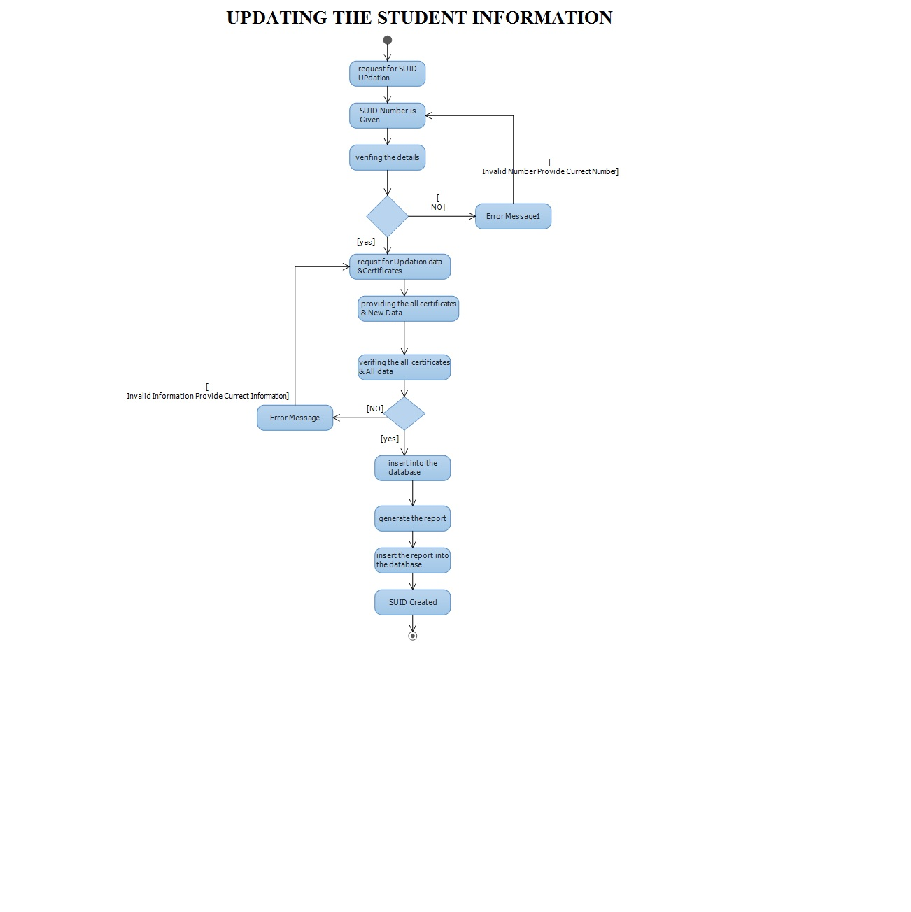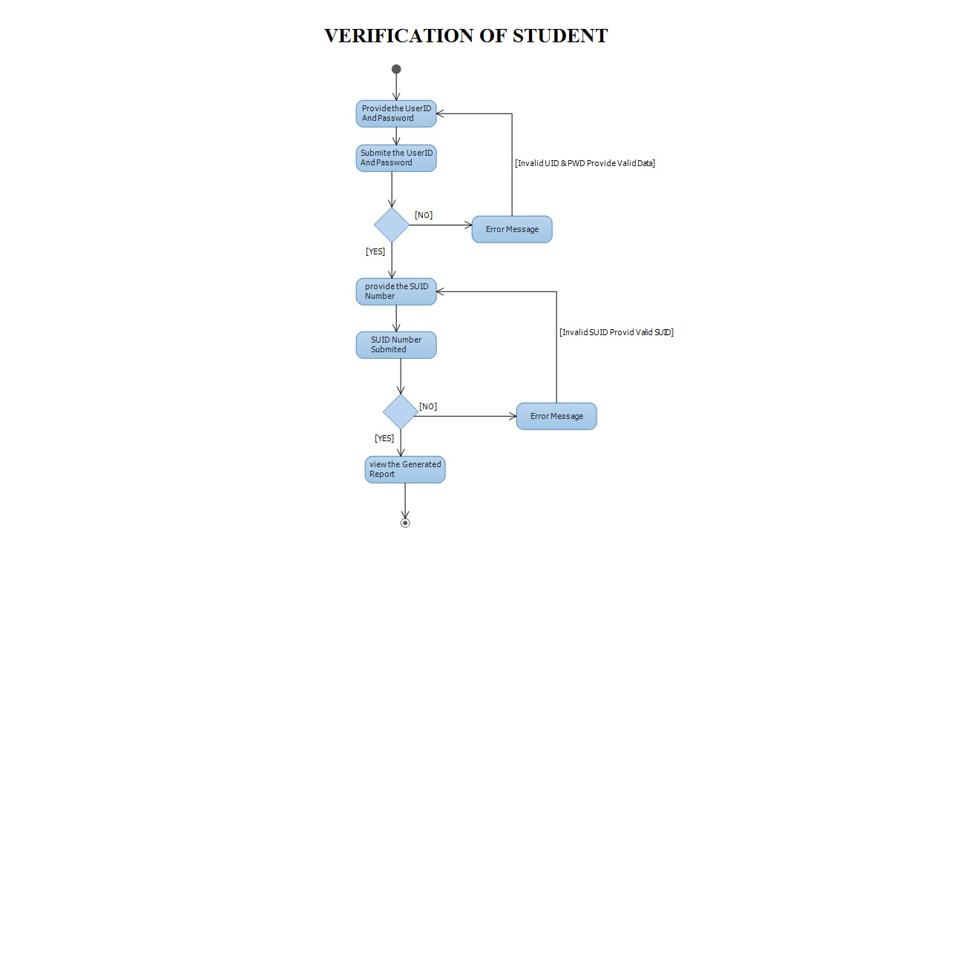

**Entities in SUID Project**

* Admin
* SUID Staff
* Exam Controller
* Company Person
* Education Department
* Student
* Status Report
* Interview Panel
* Entrance Exam
* Login

**Login**

1. User ID
2. Password
3. Role

**Admin**

1. User ID
2. Password
3. Registration Number

**SUID Staff**

1. User ID
2. Password
3. Registration Number
4. Staff Name
5. Location

**Exam Controller**

1. User ID
2. Password
3. Registration Number
4. Exam Controller Name
5. Location

**Company Persons**

1. User ID
2. Password
3. Company Name
4. Registration Number
5. Employee Name/Interviewer Name
6. Location

**Education Department**

* SSC/10th

1. Board Name
2. Roll Number
3. Student Name
4. Marks/ Grade
5. Certificate

* Inter/10+2

1. Board Name
2. Roll Number
3. Student Name
4. Marks/ Grade
5. Certificate

* UG

1. University Name
2. Roll Number
3. Student Name
4. Marks/ Grade
5. Certificate

* PG

1. University Name
2. Roll Number
3. Student Name
4. Marks/ Grade
5. Certificate

**Student**

* User ID
* Password
* Student Identification Number**(SUID)**
* Student Name
* Gender
* Age or Date of Birth
* Current Address
* City
* State
* Pin code
* Contact Number
* Father Name
* Mother Name
* PAN Number
* Passport Number
* Driving License
* SSC/10th

1. Board Name
2. Roll Number
3. Marks/ Grade
4. Certificate

* Inter/10+2

1. Board Name
2. Roll Number
3. Marks/ Grade
4. Certificate

* UG

1. University Name
2. Roll Number
3. Marks/ Grade
4. Certificate

* PG

1. University Name
2. Roll Number
3. Marks/ Grade
4. Certificate

* Photo Graph of the Student

**Status Report**

1. Student Identification Number
2. Student Name
3. Student Photo
4. Remarks On Student
5. Status

**Interview Panel**

1. Student Identification Number
2. Student Name
3. Student Photo
4. Status

**Entrance Exam**

1. Student Identification Number
2. Student Name
3. Student Photo
4. Status